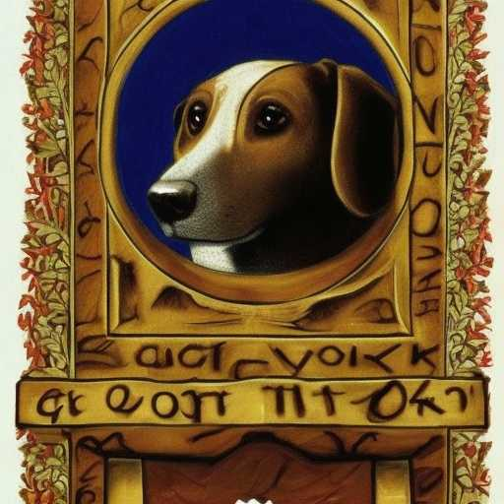
SOLOMON’S WORK DOG

I can't go back
Only forward
I can longer be a dog
I can barely even visit that irreducible rascal these days
I have lost my taste for wasting time
I have found Solomon's work
Along with his temptations
And only Grace from the Most High
Can grant access to Greater Fruits
When I take the lesser part
She cannot be the Greater

So let Her give you what She will when She will
Charming her towards benevolence will be your work

